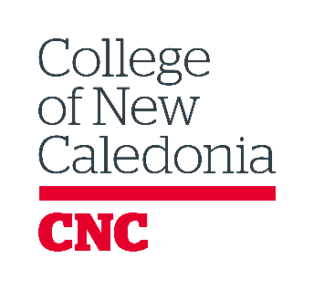

FINANCIAL AID & AWARDS

Lieutenant Governor’s Medal for Inclusion, Democracy, and Reconciliation
Nomination Form 2025-2026
Instructions: After reviewing the nomination instructions, complete this form as it pertains to you. CNC faculty and staff members nominating a student must complete the CNC faculty/staff portion of the application. Students who are self-nominating must complete the student self-nomination portion of this form.
To be considered, completed applications, including required supporting documents, must be returned to Financial Aid & Awards on or before April 3, 2026. Nomination packages can be emailed to finaid@cnc.bc.ca or delivered to the Financial Aid Office..

CNC Faculty/Staff

I, ________________________________________________, would like to nominate the following student as a potential candidate for the Lieutenant Governor’s Medal program. I have included a letter of recommendation outlining the reasons I believe this student should be considered.

Student Name (First and Last): _________________________________________________
Student # ___________________________

Date: ___________________________

Student Self-Nomination

I, ________________________________________________, would like to be considered a candidate for the Lieutenant Governor’s Medal.

___________________________________________________ ________________________________
PRINT/TYPE First and Last Name Student Number

___________________________________________________ ________________________________ ________________
Street Address City, Province Postal Code

___________________________________________________ ________________________________
Email Address Phone Number

In addition to this nomination form, I have provided all of the following documents as described in the nomination instructions:

- 500-750 word essay
- Letter of recommendation
- Summary of community/school involvement

Student Declaration

If awarded this medal, I authorize the Financial Aid & Awards office to release my personal contact information to the donor, if requested: first and last name, telephone number, mailing and email addresses, and information relative to the special requirements of this award.

I hereby declare that the information provided is, to the best of my knowledge, true and correct.

___________________________________________________ ________________________________
Student Signature Dated

