Completed by: |  | Completed Date:
Requested by: |  | Request Date:
Current CNC Policy:
Other Related Policies:
Applicable Legislation:
Exemplar Policies Identified:
Detailed Scan Notes:

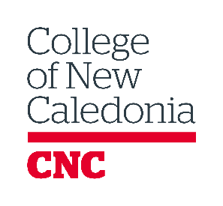
POLICY SCAN TEMPLATE

BC Post-Secondary Institutions
Institution Name | Policy Name / Link | Relevant Notes
British Columbia Institute of Technology (BCIT)
Camosun College (CAM)

Capilano University (CAP)

Coast Mountain College (CMNT)

College of the Rockies (COTR)

Douglas College
(DOUG)

Emily Carr University of Art and Design (ECUAD)
Justice Institute of British Columbia
(JIBC)
Kwantlen Polytechnic University (KWAN)
Langara College (LANG)

Nicola Valley Institute of Technology (NVIT)
North Island College
(NIC)

Northern Lights College (NLC)

Okanagan College
(OKG)

Royal Roads University (RRU)

Selkirk College (SELK)

Simon Fraser University (SFU)

Thompson Rivers University (TRU)

University of British Columbia (UBC)

University of Northern British Columbia (UNBC)
University of the Fraser Valley (UFV)

University of Victoria
(UVIC)

Vancouver Community College (VCC)
Vancouver Island University (VIU)

Other Canadian Post-Secondary Institutions
Institution Name | Policy Name / Link | Relevant Notes
College name | Link to policy
College name | Link to policy

Report a broken link or send suggestions to policy@cnc.bc.ca.

