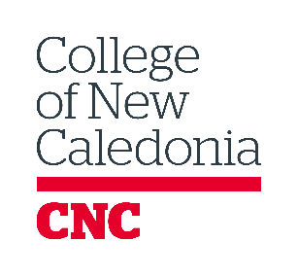
Education Council Program Profile
School responsible for the program outline
Department responsible for the program outline information
Implementation Date: Fall 20XX
Admission Type: | ☐ OPEN | ☐ LIMITED | ☐ SELECTIVE
Program Description
Write in white spaces.
Program Objectives
Admission Requirements
Selection Process (if admission type is selective)
Program Specific Requirements (Indicate additional requirements, such as consent to criminal records checks, readmission criteria, and advanced standing opportunities.
Write these requirements exactly as they should appear in the calendar.)
Program Specific Recommendations (Specify any additional information that is not a requirement for the program or graduation but will enhance student success.)
Graduation requirements: (Outline minimum grades for all courses or a minimum overall GPA required to obtain the credential.)
Course Code | Course Title |  | Credits
One of the following:
One elective chosen from:
Notes: Write any additional information; for example, “No course may be used more than once to meet diploma requirements.”  Delete this section if not needed. |  |  | Total Credits

Credential: (See CNC Education Council Procedure for College Credentials Policy (1.10))
Graduation/Time Frames: The CNC Ten Year Timeline for Program Completion Policy (E-1.37) applies by default to all programs. It is only necessary to complete this section if the program has or is seeking approval for a shorter program completion deadline.
Residency Rate Requirement: Residency rates as outlined in the College Credentials Policy Procedures (E-1.10) apply by default to all programs. It is only necessary to complete the section below if the program has specific regulatory body requirements that require a higher residency rate at the institution issuing the credential.

